# Inspecting a DataFrame

This document includes the question, the solution, and a breakdown of the code provided in the screenshot.

## Uploaded Screenshot

Below is the screenshot of the task:

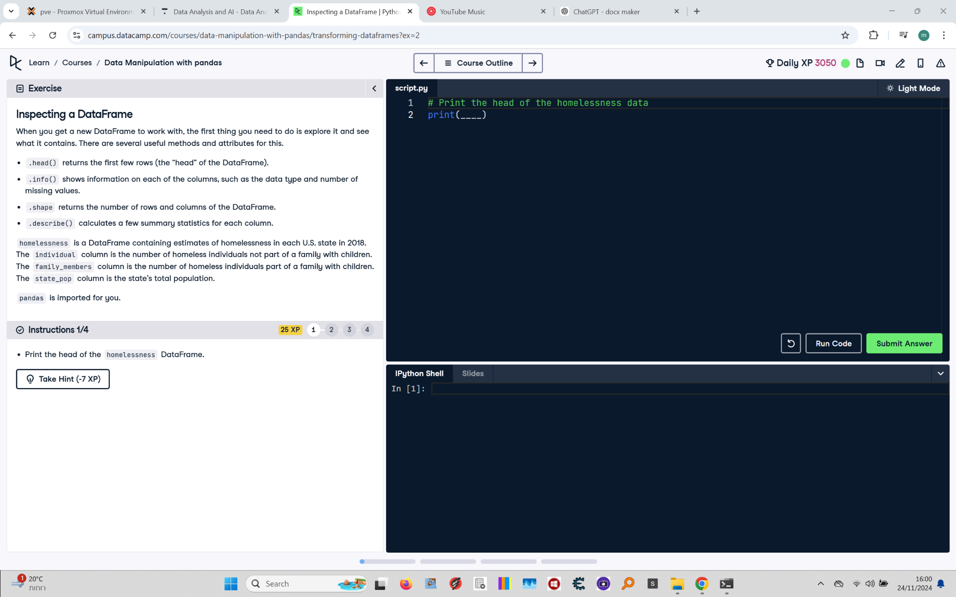

## Question

Print the head of the homelessness DataFrame.

## Answer

# Print the head of the homelessness data  
print(homelessness.head())

## Code Explanation

# Explanation of the code:

1. `print(homelessness.head())`: This line prints the first five rows of the DataFrame `homelessness`.

- The `head()` method is a built-in pandas function that retrieves the first few rows (default is 5) of a DataFrame.

- `homelessness` is a predefined pandas DataFrame containing data about homelessness in each U.S. state in 2018.